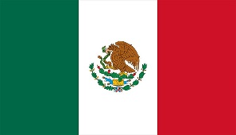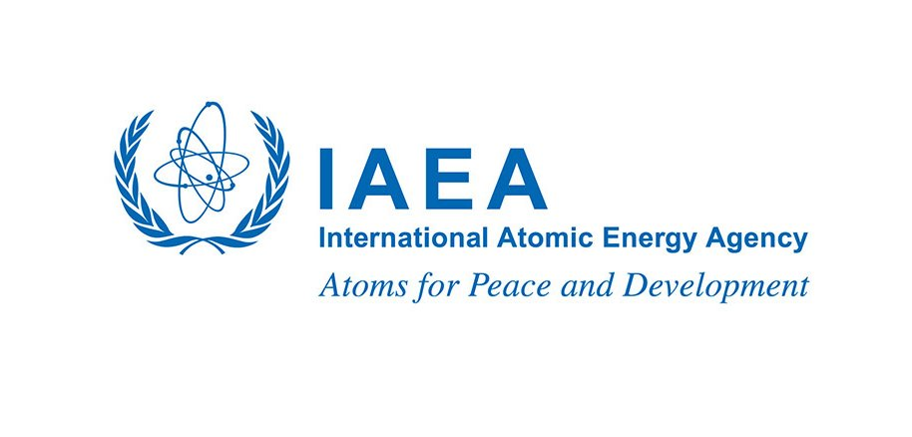

**Gender Matters, Innovation, Technological Change and Education**

Virtual Joint Side Event

Commission on the Status of Women, Sixty-Seventh Session, 2023

(**ANNOUNCEMENT**)

On Wednesday, 15 March 2023 from 08:30 am to 10:00 am EST the Permanent Missions to the United Nations of Mexico, Argentina, and Japan and the International Atomic Energy Agency (IAEA) will host a Virtual Joint Side Event on ***Gender Matters, Innovation, Technological Change and Education*** showcasing the testimonies of fellows from each country awarded a fellowship under the IAEA Marie Sklodowska-Curie Fellowship Programme. Initiated in 2020 by IAEA Director General Rafael Mariano Grossi, the programme aims to boost the number of women pursuing careers in the nuclear field in furtherance of a more inclusive and balanced workforce to contribute to and drive global nuclear policy and science and technological innovation for years to come.

**When Wednesday, 15 March 2023 from 08:30 am to 10:00 am EST New York**

(13:30 hr to 15:00 hr Vienna time[1])

**Link** Webex meeting registration link:

[https://iaea.webex.com/weblink/register/r528b7750fd565ad43cead9596c845b25](https://eur02.safelinks.protection.outlook.com/?url=https%3A%2F%2Fiaea.webex.com%2Fweblink%2Fregister%2Fr528b7750fd565ad43cead9596c845b25&data=05%7C01%7Cbrown%40un.org%7C7c92166ae47c4d37c72308db1b3e1ca7%7C0f9e35db544f4f60bdcc5ea416e6dc70%7C0%7C0%7C638133726172614744%7CUnknown%7CTWFpbGZsb3d8eyJWIjoiMC4wLjAwMDAiLCJQIjoiV2luMzIiLCJBTiI6Ik1haWwiLCJXVCI6Mn0%3D%7C3000%7C%7C%7C&sdata=ShHsGEy5hSXGT3RvuyzjNcTGNQ5103dyK%2F0kZTMi0cE%3D&reserved=0)

**Programme**: **Moderator**

*Ms. Tracy Brown*, IAEA Liaison Office New York

**Introduction**

*Ms. Vivian Okeke,* Representative of the IAEA Director General to the United Nations

**Remarks**

*H.E. Ambassador Alicia Buenrostro Massieu*

Deputy Permanent Representative, Permanent Mission of Mexico to the United Nations

*Mr. Fabián Oddone* (TBC)

Deputy Permanent Representative, Permanent Mission of Argentina to the United Nations

*H.E. Ambassador Mitsuko Shino*

Deputy Permanent Representative, Permanent Mission of Japan to the United Nations

*Ms. Maria Naydenova*

Project Manager, IAEA Marie Sklodowska-Curie Fellowship Programme

*Ms. Haruko Tateyama*, IAEA Marie Sklodowska-Curie Fellow from Japan

IAEA Marie Sklodowska-Curie Fellow from Argentina (TBC)

IAEA Marie Sklodowska-Curie Fellow from Mexico (TBC)

**Q&A Interactive Discussion**

**Conclusion**

*Ms. Vivian Okeke,* Representative of the IAEA Director General to the United Nations

**Gender Matters in Innovation, Technological Change and Education**

Virtual Joint Side Event

Commission on the Status of Women, Sixty-Seventh Session, 2023

(**CONCEPT NOTE**)

**The Marie Sklodowska-Curie Fellowship Programme**

The International Atomic Energy Agency’s Marie Sklodowska-Curie Fellowship Programme (MSCFP) aims to help increase the number of women in the nuclear field to support an inclusive workforce of both men and women to contribute to and drive global scientific and technological innovation.

Named after pioneer physicist and twice Nobel Prize laureate Marie Sklodowska-Curie, the Programme aims to inspire and encourage young women to pursue a career in the nuclear field, by providing highly motivated female students with scholarships for Master’s programmesand an opportunity to pursue an internship facilitated by the IAEA. Consideration is given to field of study, and geographic and linguistic diversity.

**The importance of women in science**

Scientific breakthroughs have given the world previously unimaginable benefits. Marie Sklodowska-Curie's pioneering work on radioactivity in the late 1800s enabled us to harness the power of the atom, producing countless benefits to humankind.

As the world faces pressures from a changing climate, growing populations, food insecurity and increased energy demand, maintaining a qualified workforce to drive innovation and productivity is all the more crucial. Nuclear related studies can help countries tackle several of these challenges, and the demand is high for qualified professionals in this field and will continue to grow.

In its unique mandate to accelerate and enlarge the peaceful uses of nuclear energy, the IAEA is at the forefront of research and technology transfer and depends on a stable pool of qualified technical professionals to fulfil its mission. This workforce does and must include women. Women, however, are far from being adequately represented in the nuclear field. The Marie Sklodowska-Curie Fellowship Programme works to help women build capacity to enhance the workforce of the future.

Come listen to testimonies from some of the fellows and representatives from their governments speak about the impact of the programme on their lives, their studies, and their governments. This year the side event will feature fellows from Argentina, Japan, and Mexico.

1. From 12 March (USA shift) to 26 March (European shift) the time difference between New York and Vienna is +5 hours instead of +6 hours due to the respective shifts to Daylight Savings Time.